H.T No
Regulations:
A17


Sreenidhi Institute of Science and Technology
(An Autonomous Institution)
Code No:6B306 Date: 14-Dec-2019 (FN)

B.Tech II-Year I-Semester External Examination, Dec-2019/Jan-2020 (Supplementary)
Mechanics of Solids (ME)

Time: 3 Hours Max.Marks:75

Note: a) No additional answer sheets will be provided.
b) All sub-parts of a question must be answered at one place only, otherwise it will not be valued.
c) Missing data can be assumed suitably.

Part - A Max.Marks:25

Answer all QUESTIONS.

1. | Draw the stress strain diagram for a ductile material. | [3M]
2. | What is the purpose of Mohr circle? | [3M]
3. | Draw neat diagrams of overhang beam and fixed beam. | [3M]
4. | What are the assumptions in bending equations? | [3M]
5. | Write the expressions for deflection of free end of cantilever beam with uniform and varying load over the entire length. | [3M]
6. | Write the applications of thin and thick cylinders. | [2M]
7. | Define Poisson ratio and lateral strain. | [2M]
8. | What is the relation between the load, shear force and bending moment? | [2M]
9. | How do you determine the section modulus of shaft with rectangular cross section? | [2M]
10. | Define torsional rigidity and torsional stiffness. | [2M]
Part – B Max.Marks:50
ANSWER ANY FIVE QUESTIONS. EACH QUESTION CARRIES 10 MARKS.

11. | a) | A specimen of steel 20mm diameter with a gauge length of 200mm is tested to destruction. It has an extension of 0.25mm under a load of 80kN and the load at elastic limit is 102kN. The maximum load is 130kN. The total extension at fracture is 56mm and diameter at neck is 15mm. Find  (i) The stress at elastic limit.  (ii) Young’s modulus.  (iii) Percentage elongation.  (iv) Percentage reduction in area.  (v) Ultimate tensile stress. | [5M]
 | b) | As shown in Fig., there is a gap between the aluminum bar and the rigid slab that is supported by two copper bars. At 10°C, Δ = 0.18mm. Neglecting the mass of the slab, calculate the stress in each rod when the temperature in the assembly is increased to 95°C. For each copper bar, A= 500mm², E = 120GPa, and α = 16.8μm/(m·°C). For the aluminum bar, A = 400mm², E = 70GPa, and α = 23.1 μm/(m·°C).  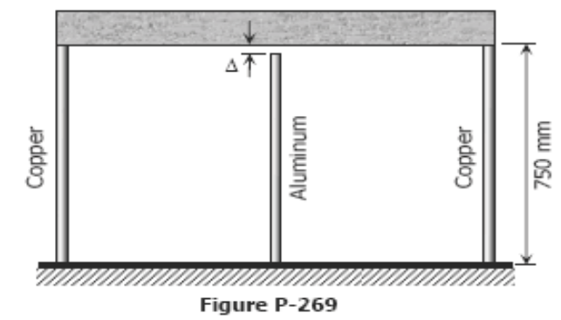 | [5M]
12. |  | State of stress at a point in a material is as shown in the Fig. Determine.  (i) principal stresses.  (ii) maximum shear stress.  (iii) plane of maximum shear stress and  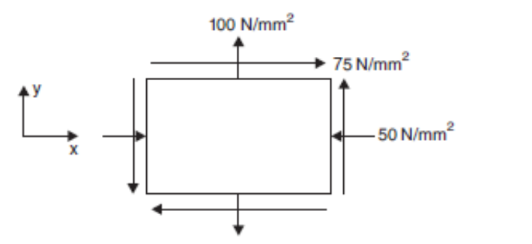  (iv) the resultant stress on the plane of maximum shear stress. | [10M]
13. |  | 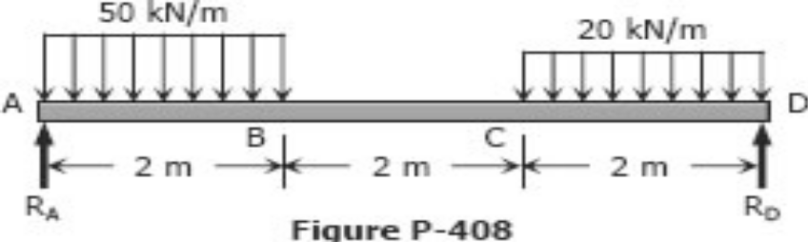  Draw the shear force and bending moment diagram for the beam shown in fig | [10M]
14. |  | The unsymmetric I-section shown in Fig. is the cross-section of a beam, which is subjected to a shear force of 60 kN. Draw the shear stress variation diagram across the depth.  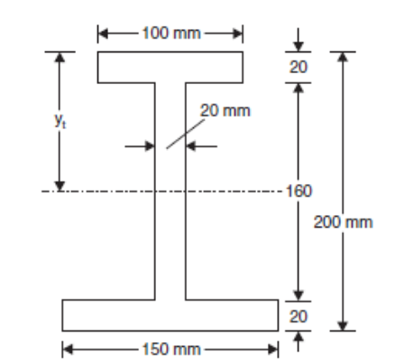 | [10M]
15. |  | Find the angle of rotation and deflection at the free end B of a cantilever beam AB with a uniform load of intensity q acting over the right-hand half of the length using moment area method  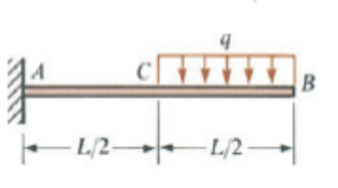 | [10M]
16. |  | Derive the expressions for effect of internal pressure on the dimensions of a thin cylindrical pressure . | [10M]
17. |  | A solid steel shaft of diameter 60 mm and length 4 m is to be designed using an allowable shear stress 40 MPa and an allowable angle of twist per unit length 1⁰ per meter. (a) Determine the maximum permissible torque that may be applied ta the shaft, assuming G = 80 GPa. (b) Determine the angle of twist. | [10M]
18. |  | A 50-mm diameter bar is used as a simply supported beam 3 m long. Determine the largest uniformly distributed load that can be applied over the right two-thirds of the beam if the flexural stress is limited to 50 MPa. | [10M]

-- 00 -- 00 –

